#
# 20171101
# Text was taken from “new server/20171031 SD#782645 Configure Oracle linux server”.

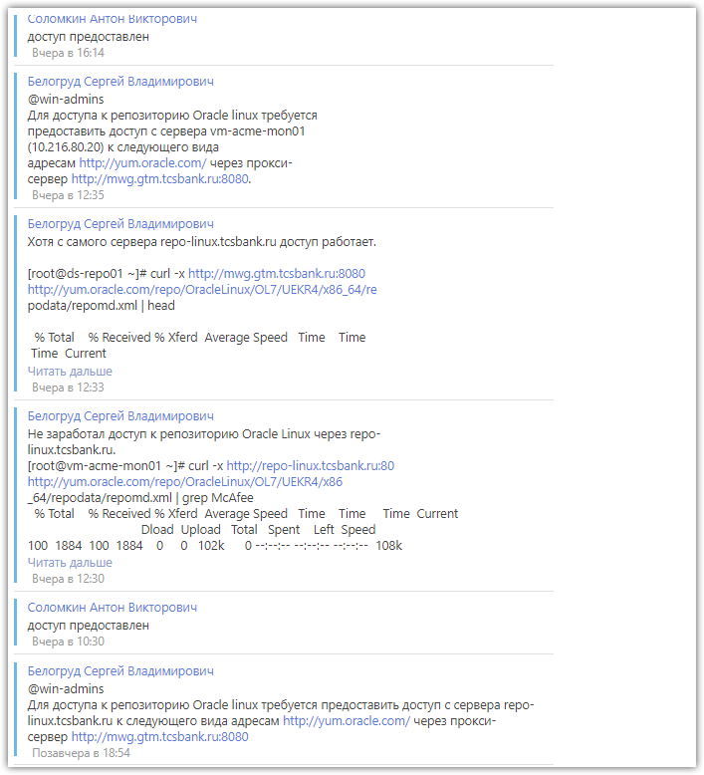

................................................................................

#
# This bitch doesn't work thrue proxy.
# I cannot install puppet without access to Oracle Linux repositoryes.
#

#
# Directly from repo-linux I can get access to required repository server.
# It's become true after Solomkin grant appropriate allowance on its proxy.
#
[root@ds-repo01 ~]# curl -x http://mwg.gtm.tcsbank.ru:8080 http://yum.oracle.com/repo/OracleLinux/OL7/UEKR4/x86_64/repodata/repomd.xml | head
% Total % Received % Xferd Average Speed Time Time Time Current
Dload Upload Total Spent Left Speed
103 1240 103 1240 0 0 13891 0 --:--:-- --:--:-- --:--:-- 14588
<?xml version="1.0" encoding="UTF-8"?>
<repomd xmlns="http://linux.duke.edu/metadata/repo">
<data type="other">
<location href="repodata/other.xml.gz"/>
<checksum type="sha">d66e2ba734d43d22fbee80b993d8fb4b120887b6</checksum>
<timestamp>1508898432</timestamp>
<open-checksum type="sha">055a157d487006801ea91c340f6b1f871046a494</open-checksum>
</data>
<data type="filelists">
<location href="repodata/filelists.xml.gz"/>
You have new mail in /var/spool/mail/root
[root@ds-repo01 ~]#

#
# But I still cannot get access via our proxy to Oracle repos.
#
[root@vm-acme-mon01 ~]# curl -v -x http://repo-linux.tcsbank.ru:80 http://yum.oracle.com/repo/OracleLinux/OL7/UEKR4/x86_64/repodata/repomd.xml
* About to connect() to proxy repo-linux.tcsbank.ru port 80 (#0)
* Trying 10.216.42.6...
* Connected to repo-linux.tcsbank.ru (10.216.42.6) port 80 (#0)
> GET http://yum.oracle.com/repo/OracleLinux/OL7/UEKR4/x86_64/repodata/repomd.xml HTTP/1.1
> User-Agent: curl/7.29.0
> Host: yum.oracle.com
> Accept: */*
> Proxy-Connection: Keep-Alive
>
< HTTP/1.1 401 authenticationrequired
< Server: nginx/1.4.4
< Date: Tue, 31 Oct 2017 09:14:09 GMT
< Content-Type: text/html
< Content-Length: 1884
< Connection: keep-alive
< Cache-Control: no-cache
< WWW-Authenticate: NTLM
< WWW-Authenticate: Basic realm="McAfee Web Gateway"
<
<!DOCTYPE html PUBLIC "-//W3C//DTD XHTML 1.0 Transitional//EN" "http://www.w3.org/TR/xhtml1/DTD/xhtml1-transitional.dtd">
<html>
<!-- FileName: index.html
Language: [en]
-->
<!--Head-->
<head>
<meta content="text/html; charset=UTF-8" http-equiv="Content-Type">
<meta http-equiv="X-UA-Compatible" content="IE=7" />
<title>McAfee Web Gateway - Notification</title>
<script src="/mwg-internal/de5fs23hu73ds/files/javascript/sw.js" type="text/javascript" ></script>
<link rel="stylesheet" href="/mwg-internal/de5fs23hu73ds/files/default/stylesheet.css" />
</head>
<!--/Head-->
<!--Body-->
<body onload="swOnLoad();">
<table class='bodyTable'>
<tr>
<td class='bodyData' background='/mwg-internal/de5fs23hu73ds/files/default/img/bg_body.gif'>
<!--Logo-->
<table class='logoTable'>
<tr>
<td class='logoData'>
<a href='http://www.mcafee.com'>
<img src='/mwg-internal/de5fs23hu73ds/files/default/img/logo_mwg.png'></a>
</td>
</tr>
</table>
<!--/Logo-->
<!--Contents-->

<!--/Contents-->
<!--Policy-->
<table class='policyTable'>
<tr>
<td class='policyHeading'>
<hr>
Company Acceptable Use Policy
</td>
</tr>
<tr>
<td class='policyData'>
This is an optional acceptable use disclaimer that appears on every page. You may change the wording or remove this section entirely in index.html.
</td>
</tr>
</table>
<!--/Policy-->
<!--Foot-->
<table class='footTable'>
<tr>
<td class='helpDeskData' background='/mwg-internal/de5fs23hu73ds/files/default/img/bg_navbar.jpg'>
For assistance, please contact your system administrator.
</td>
</tr>
<tr>
<td class='footData'>
generated <span id="time">2017-10-31 12:14:09</span> by McAfee Web Gateway
<br />
curl/7.29.0
</td>
</tr>
</table>
<!--/Foot-->
</td>
</tr>
</table>
</body>
<!--/Body-->
</html>
* Connection #0 to host repo-linux.tcsbank.ru left intact
[root@vm-acme-mon01 ~]#

................................................................................

[root@vm-acme-mon01 ~]# curl -x http://repo-linux.tcsbank.ru:80 http://yum.oracle.com/repo/OracleLinux/OL7/UEKR4/x86_64/repodata/repomd.xml | grep McAfee
% Total % Received % Xferd Average Speed Time Time Time Current
Dload Upload Total Spent Left Speed
100 1884 100 1884 0 0 102k 0 --:--:-- --:--:-- --:--:-- 108k
<title>McAfee Web Gateway - Notification</title>
generated <span id="time">2017-10-31 12:28:06</span> by McAfee Web Gateway
[root@vm-acme-mon01 ~]#

................................................................................

[root@vm-acme-mon01 ~]# telnet mwg.gtm.tcsbank.ru 8080
Trying 10.218.6.51...
Connected to mwg.gtm.tcsbank.ru.
Escape character is '^]'.
}{^]

telnet> quit
Connection closed.
[root@vm-acme-mon01 ~]# telnet repo-linux.tcsbank.ru 80
Trying 10.216.42.6...
Connected to repo-linux.tcsbank.ru.
Escape character is '^]'.
^]

telnet> quit
Connection closed.
[root@vm-acme-mon01 ~]#

................................................................................

#
# I've asked Solomkin direct access from server to proxy.
#

[root@vm-acme-mon01 ~]# curl -x http://mwg.gtm.tcsbank.ru:8080 http://yum.oracle.com/repo/OracleLinux/OL7/UEKR4/x86_64/repodata/repomd.xml | head
% Total % Received % Xferd Average Speed Time Time Time Current
Dload Upload Total Spent Left Speed
100 1240 100 1240 0 0 7204 0 --:--:-- --:--:-- --:--:-- 7251
<?xml version="1.0" encoding="UTF-8"?>
<repomd xmlns="http://linux.duke.edu/metadata/repo">
<data type="other">
<location href="repodata/other.xml.gz"/>
<checksum type="sha">d66e2ba734d43d22fbee80b993d8fb4b120887b6</checksum>
<timestamp>1508898432</timestamp>
<open-checksum type="sha">055a157d487006801ea91c340f6b1f871046a494</open-checksum>
</data>
<data type="filelists">
<location href="repodata/filelists.xml.gz"/>
[root@vm-acme-mon01 ~]#

................................................................................

#
# Only two section were enabled by default.
#
[root@vm-acme-mon01 ~]# vim /etc/yum.repos.d/public-yum-ol7.repo
[ol7_latest]
name=Oracle Linux $releasever Latest ($basearch)
baseurl=http://yum.oracle.com/repo/OracleLinux/OL7/latest/$basearch/
gpgkey=file:///etc/pki/rpm-gpg/RPM-GPG-KEY-oracle
gpgcheck=1
enabled=1
proxy=http://mwg.gtm.tcsbank.ru:8080
...

[ol7_UEKR4]
name=Latest Unbreakable Enterprise Kernel Release 4 for Oracle Linux $releasever ($basearch)
baseurl=http://yum.oracle.com/repo/OracleLinux/OL7/UEKR4/$basearch/
gpgkey=file:///etc/pki/rpm-gpg/RPM-GPG-KEY-oracle
gpgcheck=1
enabled=1
proxy=http://mwg.gtm.tcsbank.ru:8080

...

#
# Now I can get approppreated packages and its relative.
#
[root@vm-acme-mon01 ~]# yum repolist
Loaded plugins: ulninfo
ol7_UEKR4 | 1.2 kB 00:00:00
ol7_latest | 1.4 kB 00:00:00
tcs-puppetlabs-el-products | 2.5 kB 00:00:00
(1/5): ol7_latest/x86_64/group | 681 kB 00:00:00
(2/5): ol7_UEKR4/x86_64/updateinfo | 130 kB 00:00:00
(3/5): ol7_latest/x86_64/updateinfo | 1.6 MB 00:00:00
(4/5): ol7_UEKR4/x86_64/primary | 23 MB 00:00:06
(5/5): ol7_latest/x86_64/primary | 30 MB 00:00:08
ol7_UEKR4 471/471
ol7_latest 23117/23117
repo id repo name status
ol7_UEKR4/x86_64 Latest Unbreakable Enterprise Kernel Release 4 for Oracle Linux 7Server (x86_64) 471
ol7_latest/x86_64 Oracle Linux 7Server Latest (x86_64) 23,117
tcs-puppetlabs-el-products/7Server/x86_64 Puppet Labs Products El 7Server - x86_64 17
repolist: 23,605
[root@vm-acme-mon01 ~]#

................................................................................

[root@vm-acme-mon01 ~]# yum install http://repo-linux.tcsbank.ru/puppetlabs/yum/puppetlabs-release-el-7.noarch.rpm
%s/yum.puppetlabs.com/repo-linux.tcsbank.ru\/puppetlabs\/yum/gc

[root@vm-acme-mon01 ~]# mkdir -p ~/work/20171031-1831
[root@vm-acme-mon01 ~]# mv /etc/yum.repos.d/tcs-puppetlabs-el.repo !$/
mv /etc/yum.repos.d/tcs-puppetlabs-el.repo ~/work/20171031-1831/
[root@vm-acme-mon01 ~]#

[root@vm-acme-mon01 ~]# yum install puppet

................................................................................

[root@vm-acme-mon01 ~]# systemctl start puppet
[root@vm-acme-mon01 ~]# systemctl enable puppet

................................................................................

[root@puppet modules]# for var1 in vm-acme-mon01.tcsbank.ru ; do echo -e "\n${var1}" ; rake -f /usr/share/puppet-dashboard/Rakefile RAILS_ENV=production node:addgroup name=${var1} group=all-servers ; done

vm-acme-mon01.tcsbank.ru
Node groups successfully edited for vm-acme-mon01.tcsbank.ru!
[root@puppet modules]#
[root@puppet modules]# for var1 in vm-acme-mon01.tcsbank.ru ; do echo -e "\n${var1}" ; rake -f /usr/share/puppet-dashboard/Rakefile RAILS_ENV=production node:classes name=${var1} classes="etckeeper,tcs_repos::epel,tcs_repos::puppet" ;
done

vm-acme-mon01.tcsbank.ru
Node classes successfully edited for vm-acme-mon01.tcsbank.ru!
[root@puppet modules]# for var1 in vm-acme-mon01.tcsbank.ru ; do echo -e "\n${var1}" ; rake -f /usr/share/puppet-dashboard/Rakefile RAILS_ENV=production node:addclass name=${var1} class="tcs_nrpe" ; done

vm-acme-mon01.tcsbank.ru
Node classes successfully edited for vm-acme-mon01.tcsbank.ru!
[root@puppet modules]# grep -ire aronch accounts/
accounts/manifests/avaya.pp: group { 'a.aronchikov':
accounts/manifests/avaya.pp: user { 'a.aronchikov':
accounts/manifests/avaya.pp: home => '/home/a.aronchikov',
accounts/manifests/avaya.pp: comment => 'Aronchikov Andrey,BC Diapazone,2139',
accounts/manifests/avaya.pp: require => Group['a.aronchikov'],
[root@puppet modules]# vim accounts/manifests/avaya.pp
[root@puppet modules]# rake -f /usr/share/puppet-dashboard/Rakefile RAILS_ENV=production nodeclass:list | grep -ie "accounts" | egrep "aronch"
[root@puppet modules]# rake -f /usr/share/puppet-dashboard/Rakefile RAILS_ENV=production nodeclass:list | grep -ie "accounts" | egrep "avaya"
accounts::avaya
[root@puppet modules]# for var1 in vm-acme-mon01.tcsbank.ru ; do echo -e "\n${var1}" ; rake -f /usr/share/puppet-dashboard/Rakefile RAILS_ENV=production node:addclass name=${var1} class="accounts::avaya" ; done

vm-acme-mon01.tcsbank.ru
Node classes successfully edited for vm-acme-mon01.tcsbank.ru!
[root@puppet modules]#

................................................................................

[root@vm-acme-mon01 ~]# yum install nfs-utils

[root@vm-acme-mon01 ~]# mkdir /opt/acme_mon_opt

[root@vm-acme-mon01 ~]# mount -v /opt/acme_mon_opt/
mount.nfs: trying text-based options 'bg,vers=3,tcp,timeo=600,rsize=65536,wsize=65536,hard,addr=10.217.67.8'
mount.nfs: prog 100003, trying vers=3, prot=6
mount.nfs: trying 10.217.67.8 prog 100003 vers 3 prot TCP port 2049
mount.nfs: prog 100005, trying vers=3, prot=6
mount.nfs: trying 10.217.67.8 prog 100005 vers 3 prot TCP port 4046
[root@vm-acme-mon01 ~]# df -hT !$
df -hT /opt/acme_mon_opt/
Filesystem Type Size Used Avail Use% Mounted on
v6250-m1:/vol/acme_mon_opt nfs 300G 192K 300G 1% /opt/acme_mon_opt
[root@vm-acme-mon01 ~]#

................................................................................

[root@vm-acme-mon01 ~]# showmount -e ds-hadoop-cs01p.tcsbank.ru
Export list for ds-hadoop-cs01p.tcsbank.ru:
/ *
[root@vm-acme-mon01 ~]# mkdir /mnt/hdfs-prod
[root@vm-acme-mon01 ~]#

[root@vm-acme-mon01 ~]# vim /etc/fstab
[root@vm-acme-mon01 ~]# mount -v /mnt/hdfs-prod
mount.nfs: trying text-based options 'bg,vers=3,tcp,timeo=600,rsize=65536,wsize=65536,hard,addr=10.218.64.10'
mount.nfs: prog 100003, trying vers=3, prot=6
mount.nfs: trying 10.218.64.10 prog 100003 vers 3 prot TCP port 2049
mount.nfs: prog 100005, trying vers=3, prot=6
mount.nfs: trying 10.218.64.10 prog 100005 vers 3 prot TCP port 4242
[root@vm-acme-mon01 ~]# df -hT !$
df -hT /mnt/hdfs-prod
Filesystem Type Size Used Avail Use% Mounted on
ds-hadoop-cs01p.tcsbank.ru:/ nfs 1.6P 1007T 541T 66% /mnt/hdfs-prod
[root@vm-acme-mon01 ~]#

................................................................................

[root@vm-acme-mon01 ~]# tail /etc/fstab
# Accessible filesystems, by reference, are maintained under '/dev/disk'
# See man pages fstab(5), findfs(8), mount(8) and/or blkid(8) for more info
#
/dev/mapper/vg_root-lvol0 / xfs defaults 0 0
/dev/mapper/vg_var-lvol0 /var xfs defaults 0 0
UUID=bfbad39c-40f5-4863-95c4-6e265d84f6e1 /boot xfs defaults 0 0

v6250-m1:/vol/acme_mon_opt /opt/acme_mon_opt nfs rw,bg,vers=3,tcp,timeo=600,rsize=65536,wsize=65536,hard 0 0

ds-hadoop-cs01p.tcsbank.ru:/ /mnt/hdfs-prod nfs ro,bg,vers=3,tcp,timeo=600,rsize=65536,wsize=65536,hard 0 0
[root@vm-acme-mon01 ~]#

................................................................................

